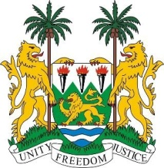
SIERRA LEONE
26th session of the UPR

ZIMBABWE

STATEMENT BY SIERRA LEONE

2 November 2016

Mr President,

Sierra Leone extends a cordial welcome to the Zimbabwean delegation and thanks them for their presentation.

My delegation commends the Government of Zimbabwe for the creation of a new Constitution in 2013, following a referendum. Harmful practices such as child marriage have since been banned through a recent Constitutional Court ruling and the striking out of Article 22 of the Marriage Act of Zimbabwe which previously allowed for the marriage of minors under certain circumstances.

Furthermore, even though it is under-resourced, it is noteworthy that Zimbabwe’s Human Rights Commission enjoys an “A” status.

Sierra Leone has the following recommendations:

- Ratify the CAT, ICRMW and the ICPPED.
- Submit its long overdue report to the relevant treaty body mechanisms.
- Increase the age of criminal responsibility to match international standards.
- Cooperate with the special procedure mandate holders of the Human rights Council by responding positively to their requests for visits.

To conclude, Sierra Leone wishes the Zimbabwe every success is completing this UPR session.

Thank you, Mr President.

